Columbus County Schools

Chromebook 1-to-1 Initiative
For 6th, 7th and 8th Graders
Parent/Student Handbook

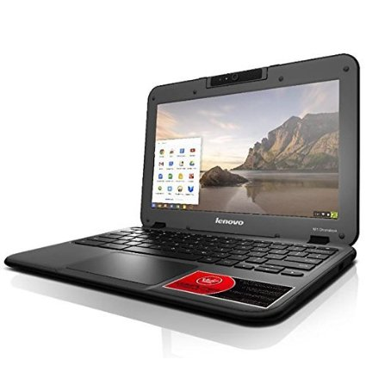

2019

Dear Student/Parent/Guardian,

In January, all 6th, 7th and 8th grade students will be receiving a Chromebook for their use at school and at home.

We are pleased to offer this program and are grateful for your support in helping us properly care for and utilize technology appropriately. The following list highlights several of our expectations for students.

Technology Guidelines:
- ChromeBooks are educational tools and should be used in that capacity.
- Do not leave ChromeBooks in automobiles. Doing so invents theft and exposes the ChromeBooks to extreme temperatures.
- ChromeBooks must come to school fully charged every day.
- Do not eat or drink near the ChromeBooks.
- Do not rest pencils/pens or other items on the keyboard. Accidentally closing the ChromeBook with items on the keyboard will damage the screen.
- Cyberbullying will not be tolerated.
- Students may download apps from the Google App store. There are many apps available which will help with educational projects.
- Students should not try to bypass the district filter in any way. This includes, but is not limited to, the use of proxy avoidance sites.

Please read the enclosed information carefully, and sign and detach the consent form.

If you have any questions or concerns about the Chromebooks or the stipulations for being able to take the Chromebooks home, please contact your child’s school.

Once again, thank you for your support!

Columbus County Schools is committed to educating all children to be productive workers, responsible citizens, and lifelong learners, enabling them to be globally competitive and prepared for life in a digital society. The 1:1 Chromebook project provides an equitable opportunity for all students to experience a technology-rich environment and to ensure our graduates are prepared for the workplace and life. Understanding of and adhering to the following policies and procedures is necessary for the success of the program.
Technology is a critical part of learning, expanding the classroom beyond traditional limits of time and space. Technology enables us to respond more effectively to the unique learning styles of today’s students. Technology expands our sense of community by changing the way teachers, students, and parents interact with each other.
Goals:
1. Teach students discernment and the ethical use of technology.

2. Improve the quality of student learning and academic achievement as they develop
knowledge and skills for the future world of work.

3. Offer greater access to educational opportunities, formative assessments, and differentiated instruction by providing one to one access of laptops for students for anytime, anywhere learning.

4. Improve communications among students, parents and teachers.

5. Equip students to be lifelong learners.

6. Through personalized, authentic, and collaborative experiences, students will solve problems and demonstrate their learning through project-based activities.

What is a Chromebook?

A Chromebook is a personal computer running the Google Chrome OS (Operating System). Although this device has some offline capabilities, such as writing papers offline, it is designed to be used while connected to the Internet. Rather than using traditional software that resides on the device itself, Chromebooks utilize web applications and cloud storage to create a unique user experience. The web applications allow the device to quickly boot upon the system startup. USB peripheral devices such as a wireless mouse or a flash drive will work, however, students will not be able to install traditional software or run executable files.
What is the Chrome Operating System (OS)?

The Chrome OS (Operating System) works with web-based applications versus traditional stand-alone software. There are no programs to load and no updates to install. The Chrome OS automatically updates, therefore, you are always running the most current version. Chrome was designed for more than just speed. Because of its advanced security features, Chrome offers a very safe browsing experience. Chrome also allows you to control what information you share online.

Why use Chromebooks?

Columbus County Schools chooses to use Chromebooks because it is an economical and efficient way for us to ensure that each student has access to a well-built device that will serve their educational needs allowing them to meet North Carolina’s state technology standards.

Information and Technology Standards

The North Carolina Information and Technology Essential Standards are integrated into your child’s everyday learning experiences. These standards are divided into four key skills that are fundamental in preparing students to be successful.
These include:
• Sources of Information
• Research Process
• Technology as a Tool
• Safety and Ethical Issues

The North Carolina General Assembly has passed a bill that requires all students beginning with the graduating class of 2019 to take an online course as part of their requirements for graduation, making these skills even more necessary for student success.

What is Google For Education

Google Apps for Education, GAFE in its shortened version, is a workplace that supports Columbus County School’s vision of anytime, anywhere learning.
GAFE can be looked at as a digital locker of sorts for students and faculty. It is a place to safely keep online communication and collaboration documents as they relate to school, school websites, school documents, school videos, school calendars, and school email.
There will be a wide variety of professional development opportunities concerning GAFE throughout the district. Instructional Technology Facilitators will work alongside teachers in every cluster to help implement the great educational apps that Google and its partners have to offer. CCS is committed to providing teachers with the resources and training they need to make GAFE a success.
Working Offline With Google Chrome

The Chromebook and its corresponding OS have the ability to work in both online and offline modes. Students who do not have access to a wireless network outside of school do not need to panic. They will be able to continue working on their device and sync their newly added data to their accounts once they have accessibility to a wireless network.

When you aren't online, you can still do lots of things with your Chromebook:
- Write emails. Gmail Offline is built to support offline access, allowing mail to be read, responded to, searched, and archived without network access. Gmail Offline will send your messages as soon as Wi-Fi is available.
- View appointments. With offline access from the Google Calendar app, you can view a read-only version of your calendar.
- View, create, and edit documents. The Google Drive app lets you view and edit Google Docs, Slides, Sheets, and Drawings files.
- View and edit photos. Your Chromebook comes with a built-in photo editor, so you can view and edit photos that are saved to your Chromebook.
- Listen to music. You can play music stored on your Chromebook when you're offline. Copy music files to your Chromebook directly from a storage device like a USB stick or SD card.
- Watch videos. You can download movies and TV episodes to watch offline with the Google Play Movies & TV app.
- View Microsoft Office and Adobe .pdf files. You can easily use your Chromebook to view Microsoft Office or Adobe files without an Internet connection.
- Take notes. With Google Keep, you can take and save short notes that will save to the cloud the next time you're online.
- Read offline web pages. If you've saved web pages for offline viewing later, they will open in Google Chrome on your Chromebook.
- Use other web apps. Some web applications also have offline counterparts, which you can find in the Chrome Web Store. These include The New York Times and Cloud Reader from Amazon.
- Play games. The Chrome Web Store offers hundreds of games, many of which are also available offline, like Angry Birds and Cube Slam.
- Some third party apps located within the domain, made available to students, do have offline capability.
- Nevertheless, as mentioned earlier, once students "hit" a wireless network, their work in
mode will sync to their account and become available with the latest updates in their Google Drive.

Cloud Print
Students can setup their Chromebooks to be able to print. Just follow the simple steps below.

IMPORTANT: You must have a computer that is already connected to your printer. Then you must log on to both the Chromebook and the computer (the one connected to the printer) the same way in Google Chrome.
- First log onto the computer that has a printer connected to it.
- Click on the Chrome Browser and sign in to Chrome. ( If you don’t already have a google account, you will need to create one).
- In the upper right corner, you will see three horizontal lines. Click on them and scroll down until you see settings.
- After you click on settings, you will need to scroll all the way to the bottom of the screen until you see the Show Advanced.
- Once you click the show advanced button you will scroll down until you see Google Cloud Print. Click on the manage button.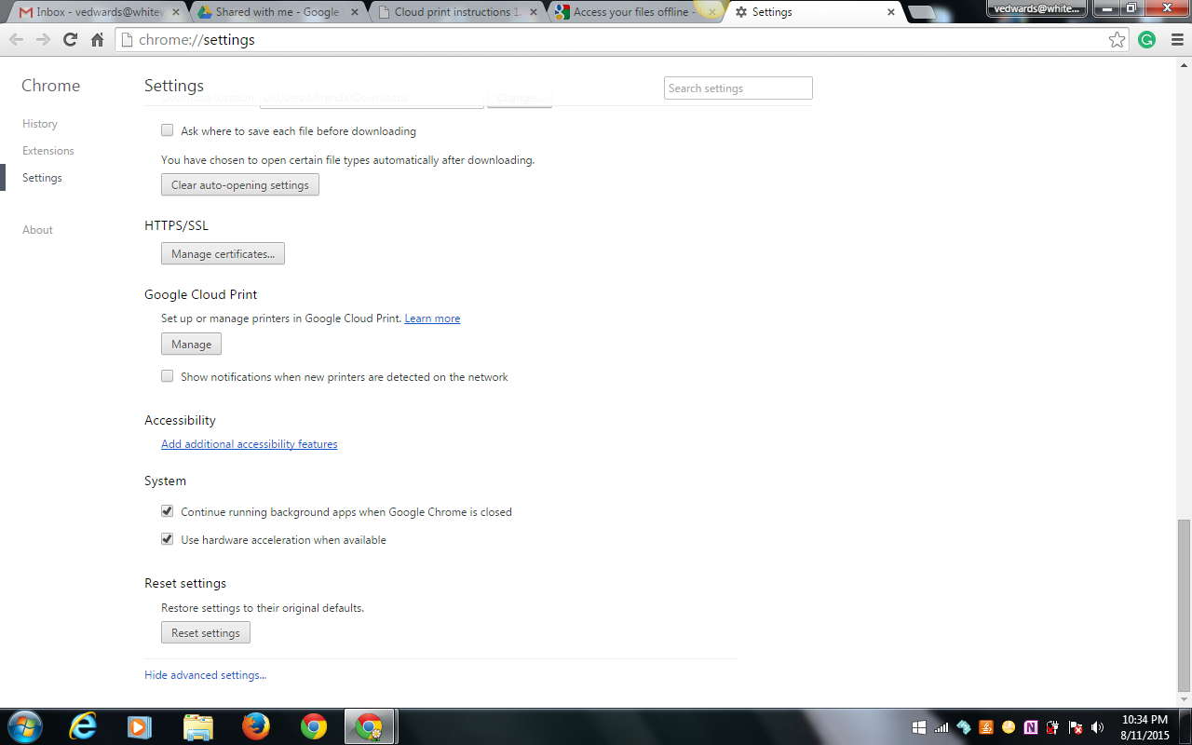
- If you have a cloud ready printer it will pick it automatically and you can click on the manage button under My devices to manage them, but if you have a classic printer (which is what most of us have) you can click on add printer under Classic printers to find the printers that are already loaded on your computer. Once you click add printer you should see the printer or printers that you have connected to that computer. You can put a check by the printer that you want to use. If there is more than one printer and you don’t want to use one, just remove the check.
8.

Once you go through the steps to setup the cloud print you, will be able to see the printers on any computer IF you are logged on to Google Chrome.
For this to work, have your student log onto your home computer which has the printer/printers loaded. Have them log into Google Chrome the same way they log onto the Chromebook. Follow the steps above. When they reach the last screen shown above, they should be able to log onto the Chromebook and see the printers when they go to cloud print. You can also choose to share the printer. If you click on print, you can put the student’s email address in and that gives them permission to use the printer. As a general rule, students will not be allowed to print at school.

While we expect students to take exceptional care of their ChromeBooks, there may be circumstances where a student damages their device. In the event that a Chromebook is damaged, the following fee schedule will apply. (This fee schedule has been developed in order to facilitate quality repairs with the lowest cost possible.):

2019 ChromeBook Damage Fees
Broken or Cracked Screen (LCD Only) | $75.00
Broken Screen Bezel | $50.00
Cracked Top Case | $50.00
Cracked Bottom Case | $50.00
Broken Charging Port | $35.00
Broken Data Ports (Logic Board) | $125.00
Broken Keyboard | $75.00
ChromeBook Charger | $50.00
ChromeBook Carrying Case  (Lost or excessive damage beyond normal wear and tear) | $45.00
Total Loss Excluding Carrying Case  (Damaged beyond repair, stolen, or repair cost exceeds replacement cost. N21 Retail is $239.00 + $30.00 Management License) | $250.00
Total Loss Including Carrying Case | $299.00

We highly recommend consulting your insurance company to explore possible options of including the Chromebook on your homeowners insurance. This has been very helpful for a few students/parents in the past.

This document was prepared with assistance from Whiteville City Schools

Student/Parent Agreement Form

- 1:1 Learning Classroom Students are obligated to bring their device to school each day charged.

- Students are not to add stickers to the laptop.

- Students are responsible for taking reasonable care of machines to ensure they are not damaged, lost, or stolen both at school and home.

- Students must follow the Columbus County Schools Acceptable Use Guidelines.

- All technical services will be addressed by the CCS Technology Services Department.

- Chromebooks should not be used/opened in the Gym unless instructed by a teacher. (Basketballs are used almost every day and these balls will destroy the Chromebook.)

- I AGREE to pay the specified damage fees if my child damages the laptop, (broken screen, liquid damage, broken laptop shell, etc.....) or loses the laptop.

- I understand that if the Chromebook is damaged beyond repair, or stolen, that I will owe the cost of $250.00. ($299.00 if loss includes the case.)

- I understand that misuse of the laptop and Internet could result in my loss of laptop privileges.

- I agree to monitor my child’s internet use while he/she is at home

Student Name (Print):_______________________________________Grade:_______________

School: ______________________________________Homeroom:__________________

Student Signature:____________________________________________________

Parent Signature:__________________________________________________________

Date: __________________________

